

MASTER’S IN BIG DATA

Predicting Novel Drug Metabolism with Neural Networks: A CYP450-Based Approach

Master's Thesis by: Gonzalo Robles Criado
Thesis Supervisor: Juan Manuel Moreno Lamparero

– Madrid, August 2025 –

Abstract
Xxx

Resumen
Xxx español
Contents
1 Abstract 3
2 Resumen 3
4 Figures 4
5 Abbreviations 5
6 Introduction 5
7 STATE OF THE ART 6
7.1 Experimental systems 6
7.2 In silico approaches 8
7.3 Molecular representations 9
8 OBJECTIVES 10
9 METHODOLOGY 10
9.1 Reproducibility & tooling 10
9.2 Data Acquisition & Management 11
9.3 Molecular Representation Strategy 11
9.3.1 Pre-training an InChI-Based Molecular Language Model for Feature Extraction (Complementary Experiment) 14
9.4 Predictive Modelling Framework 16
9.4.1 Problem definition: Multi-label classification 16
9.4.2 Model evaluation 17
9.4.3 Model Selection and Cross-Validation 19
10 RESULTS 20
10.1 Data Acquisition 20
10.1.1 InChI Database 20
10.1.2 Metabolism-related Database 20
10.2 Data source description 21
10.3 Exploratory data analysis (EDA) 22
10.3.1 InChI Database EDA 22
10.3.2 Metabolism-related Database EDA 25
10.4 Data Preprocessing 25
10.4.1 Molecular Fingerprint Generation Using Morgan Algorithm 25
10.4.2 Molecular Embedding Extraction Using MolE 26
10.4.3 Molecular Embedding Extraction Using ChemBERTa 26
10.4.4 Molecular Embedding Extraction Using Author-Trained InChI embedder 27
10.5 Feature Selection 29
10.6 Data Splitting 29
10.7 Model Training 29
10.8 Model Evaluation and Validation 29
10.9 Comparative Analysis 29
11 Conclusions 29
12 REFERENCES 29
13 Anexos 31

Tables

Figures
Figure 1. A simplified overview of hepatic drug metabolism. Phase I reactions introduce or reveal polar functional groups via processes such as oxidation, reduction, and hydrolysis. *The resulting Phase I metabolites may be directly excreted or can proceed to a subsequent conjugation step with hydrophilic molecules (Phase II reactions). Source: Original artwork by the author. 7
Figure 2. Schema of molecular representation pipelines. Source: Original artwork by the author. 13
Figure 3 Schematic representation of the RF classification process. *Threshold optimised during cross-validation per CYP. 20
Figure 4. Summary statistics of the SMILES-to-InChI conversion process, including total processed molecules, number of successful and failed conversions, overall success rate, and execution time. 27
Figure 5. CYP450 ‘dict’ descriptors for full db (A) and curated db with threshold = 50 (B). Dict( CYP name : Nº of appearances ) 28
Figure 6 Distribution of InChI string lengths with fitted log-normal distribution. The histogram represents the empirical distribution, with the x-axis truncated at the 99th percentile to improve visual clarity by excluding extreme outliers. The dashed red line corresponds to a fitted log-normal distribution, shown for reference to illustrate the overall shape of the data. 30
Figure 7 Distribution of tokenized InChI sequence lengths with fitted log-normal distribution. The x-axis is truncated at the 99th percentile for visual clarity. The fitted log-normal curve is shown for reference. 31
Figure 8. Morgan fingerprint feature matrix (ECFP6, radius = 3) for the curated dataset. Rows correspond to DrugBank IDs; columns represent hashed substructure counts. The resulting matrix has dimensions 1368 × 2048 and contains integer count values. 33
Figure 9. MolE embedding matrix for the curated dataset. Rows correspond to DrugBank IDs; columns represent pretrained embedding dimensions from the MolE transformer. The resulting matrix has dimensions 1368 × 1000 and contains continuous-valued vectors. 33
Figure 10. ChemBERTa embedding matrix for the curated dataset. Rows correspond to DrugBank IDs; columns represent pretrained embedding dimensions from the ChemBERTa transformer. The resulting matrix has dimensions 1368 × 768 and contains continuous-valued vectors. 34
Figure 11. InChI-based embedding matrix for the curated dataset. Rows correspond to DrugBank IDs; columns represent embedding dimensions from the author-trained InChI transformer. The resulting matrix has dimensions 1368 × 384 and contains continuous-valued vectors. 35

Abbreviations
df | Dataframe
CYP450 | Cytochrome P450
db | Database(s)
ML | Machine learning
SMILES | Simplified Molecular Input Line Entry System
InChI | IUPAC International Chemical Identifier
.tsv | Tab-separated values
MLM | Masked Language Model
BPE | Byte-Pair Encoding
LR | Logistic Regression
RF | Random Forest
XGBoost | Extreme Gradient Boosting
MCC | Matthews Correlation Coefficient
CV | Cross-Validation
FN | False Negatives
FP | False Positives
TP | True Positives
TN | True Negatives
HL | Hamming Loss
τ | Decision threshold

Introduction
The development of new drugs is an expensive, complex, and time intensive process requiring rigorous evaluation of safety and efficacy before clinical use. Notably, nearly 40% of drug candidates fail during clinical trials due to inadequate pharmacokinetic properties [1], [2], which profoundly influence a compound's absorption, distribution, metabolism, and excretion. Drug metabolism plays a central role in this context, determining the appropriate dosage regimen and highlighting potential adverse effects. The rate and efficiency with which a compound is metabolized directly affect its therapeutic efficacy, toxicity risk, and potential drug-drug interactions, making metabolism assessment a critical factor in drug development success.
A key family of enzymes responsible for drug metabolism is the cytochrome P450 (CYP450) superfamily, which processes the majority of marketed drugs. Identifying which CYP450 isoenzymes (i.e., subtypes) are involved in the metabolism of a new molecule is critical, as it can reveal potential issues in the clinical stage. However, this characterization is typically performed only in late preclinical or even early clinical stages, when laboratory assays and in vivo studies become economically justified. At these advanced stages, uncovering metabolism-related issues can lead to costly setbacks or even termination of a drug candidate, as redesigning its structure is often no longer economically viable. In early discovery, where many compounds are screened, routine experimental testing of CYP450 metabolism is rarely performed due to high costs, leaving potential issues undetected until very late in development.
Experimental systems such as liver microsomes and primary hepatocytes are widely used to study drug metabolism, yet each has significant trade-offs. Microsomes enable relatively low-cost, high-throughput testing, but offer only partial insights into a molecule’s metabolic profile. In contrast, primary hepatocytes provide more complete and physiologically relevant profiles, but are far more expensive, challenging to handle, and unsuitable for high-throughput jobs. As a result, detailed metabolic studies are often delayed in the development process. This challenge highlights the need for computational tools capable of predicting key metabolic behaviours early, complementing traditional experiments while reducing risk and cost [3].
The growing availability of high-quality biochemical databases (db), such as ChEMBL and DrugBank, increasingly fills this gap. These db compile extensive information on molecular structures and their known metabolic properties, providing a valuable foundation for predictive modelling. By leveraging this data, machine-learning (ML) algorithms can predict metabolic behaviour much earlier in the discovery process, offering insights that would otherwise require time-intensive and costly experiments.
This project aims to apply data science and ML techniques to predict the metabolism of new drug-like molecules, focusing on classifying the CYP450 isoenzymes most likely to metabolize them. By training models on curated molecular structure data and publicly available labels, this work seeks to provide pharmaceutical chemists with a computational tool for evaluating the effect of molecular variations in drug-metabolism. This would allow them to identify potential metabolic risks early, ultimately improving the likelihood of advancing promising drug candidates to market authorization.

STATE OF THE ART

Experimental systems
As previously introduced, the importance of the correct characterization of the metabolic profile of a clinical candidate cannot be understated. The most physiologically relevant system available for studying human drug metabolism is the use of primary hepatocytes—liver cells that retain the full complement of metabolic enzymes and cofactors found in vivo. These cells allow researchers to observe both major classes of metabolic reactions: Phase I, which generally involves functionalization of the drug (e.g., oxidation, reduction, or hydrolysis), and Phase II, which involves conjugation reactions that increase the molecule’s solubility and mass for excretion. Together, these phases represent the natural sequence of biotransformations a compound undergoes, and hepatocytes are capable of capturing both, providing an overall view of the metabolic fate of a drug candidate.
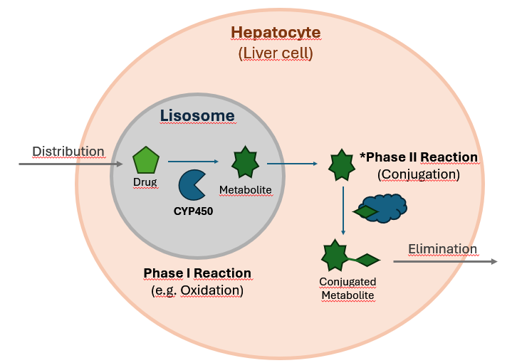
Figure 1. A simplified overview of hepatic drug metabolism. Phase I reactions introduce or reveal polar functional groups via processes such as oxidation, reduction, and hydrolysis. *The resulting Phase I metabolites may be directly excreted or can proceed to a subsequent conjugation step with hydrophilic molecules (Phase II reactions). Source: Original artwork by the author.
Because they reflect the full enzymatic and physiological context of the liver, primary hepatocytes are considered the gold standard for studying drug metabolism. They provide a near-complete representation of how a compound would behave in human systems, allowing for precise determination of metabolites, rates of clearance, and enzyme pathways involved. However, the value of hepatocytes comes with significant limitations: they are expensive, often costing hundreds of dollars per experiment, and they require specialized culture conditions and expertise. Their limited availability (due to donor dependence), relatively short lifespan, and low throughput make them unsuitable for screening large libraries of early-stage drug candidates. As a result, hepatocyte studies are typically reserved for promising molecules during late preclinical stages.
To address the need for faster and more cost-effective metabolism screening, liver microsomes have become a widely used alternative. Microsomes are subcellular fractions derived from the endoplasmic reticulum of hepatocytes, containing a concentrated pool of Phase I enzymes, particularly the CYP450 family. Although they lack the full cellular machinery required for Phase II conjugation reactions, microsomes are highly useful for early characterization of oxidative metabolism and enzyme-specific activity. Their high throughput and lower cost—often an order of magnitude cheaper than hepatocyte assays—make them particularly well suited for early drug discovery when many candidate molecules are being tested.
One important consideration in early drug metabolism studies is that Phase I reactions, which are largely mediated by CYP450 enzymes, tend to be more unpredictable and clinically significant than Phase II reactions. Phase I often introduces functional groups to a molecule, creating reactive intermediates or metabolites that can lead to drug–drug interactions or unexpected toxicity. In contrast, Phase II reactions, such as glucuronidation, typically involve conjugation with endogenous molecules, which generally renders compounds less active and more easily excreted, making these reactions less prone to harmful interactions. Since CYP450 enzymes play a dominant role in Phase I metabolism, understanding and predicting their involvement provides valuable insight into one of the most critical determinants of drug safety and efficacy.

In silico approaches
Beyond experimental systems, advances in computational power and the availability of molecular data have given rise to in silico technologies designed to predict drug metabolism. Rule-based expert systems, such as MetaSite and StarDrop (with its WhichP450™ model), attempt to forecast how molecules are processed by specific enzymes, including CYP450 isoforms. These tools offer rapid predictions and can screen large compound libraries at a scale far beyond what any in vitro system could achieve. However, their proprietary nature and high licensing costs, ranging from several thousand euros per project for MetaSite to annual subscriptions exceeding tens of thousands of euros for StarDrop, can make them less accessible, particularly for early-stage research teams or academic groups.
From a technological standpoint, these algorithmic solutions are based on a combination of mechanistic models and ML to simulate drug-enzyme interactions. StarDrop’s Semeta platform integrates enzyme-specific regioselectivity models, quantum mechanical simulations, and predictive heuristics to identify likely metabolic pathways across major Phase I and Phase II enzymes, including CYP450 isoforms [4]. MetaSite, on the other hand, leverages structure-based docking, flexible interaction fields, and structure–activity relationships (SARs) to model how xenobiotic compounds interact with enzyme active sites, ranking predicted poses through energy-based scoring functions [5]. While these approaches have proven accuracy and the advantage of incorporating detailed enzyme knowledge, they can also be computationally intensive, particularly when simulating multiple enzyme systems or large libraries of molecules.
Despite the proprietary nature of these platforms, the state of the art regarding in silico models relies heavily on ensemble modelling, a technique where multiple predictive models are combined to produce a more accurate and reliable outcome than any single model could achieve on its own. In the case of Semeta, for example, separate models such as WhichP450 and WhichEnzyme are integrated alongside regioselectivity predictors to collectively determine the most likely metabolic routes. This combined approach helps balance out the limitations of individual models by bringing together the strengths of different algorithms, leading to more reliable and accurate predictions.
Academic platforms such as CYPstrate [6], CYPReact [7], DeepP450 [8], and the metabolism modules of ADMETlab 3.0 [9] illustrate the consolidation of supervised learning for CYP450 isoform prediction. These systems typically cast metabolism as isoform-specific classification tasks, often decomposed into binary or multi-label problems, and rely on ensemble tree methods (e.g., Random Forest, gradient boosting), Support Vector Machines, or deep neural architectures operating on SMILES-derived descriptors. While differing in scale and implementation, they share a common design pattern: curated structural datasets, fixed molecular representations (fingerprints or sequence encodings), and independent models per endpoint, prioritizing statistical generalization over mechanistic enzyme simulation.

Molecular representations
Among the various chemical representations in computational chemistry, SMILES (Simplified Molecular Input Line Entry System) stands as the predominant format for encoding molecular structures. SMILES’ popularity stems from its computational efficiency and widespread support across cheminformatics tools, making it the standard input for most cheminformatics algorithms. However, SMILES is not without limitations. Its non-canonical nature means that multiple strings can represent the same molecule, complicating tasks that rely on unique identifiers. Challenges also arise when representing protonated species, compounds containing transition metals, or more complex molecular structures, where SMILES may lack precision and consistency.
To characterize molecular features for ML, chemical fingerprints are preferred over learned embeddings, particularly when datasets contain a relatively small number of compounds, usually in the thousands. Fingerprints such as MACCS keys, which provide a compact 166-bit vector, offer computational simplicity but often lack sufficient detail for predictive modelling. More informative are Morgan fingerprints [10], with adjustable lengths that capture substructural patterns. This work employs Morgan fingerprints of length 2048 bits rather than shorter alternatives like 512 or 1024, as the greater dimensionality better encodes chemical variability and subtle structural differences. Overall, fingerprints continue to dominate as the preferred molecular representation due to their efficiency and interpretability, although emerging embedding techniques have begun to attract attention for their potential to capture richer structural information.
Early work on learned molecular representations gave rise to Mol2Vec [11], proposed in 2018, which adapts natural language processing techniques to chemistry by treating molecular substructures as “words” and learning continuous vector representations using a Word2Vec-style framework. Mol2Vec demonstrated that unsupervised embeddings derived from molecular fragments could capture chemical similarity and improve performance over traditional fingerprints in some predictive tasks. More recently, advances in deep learning have led to transformer-based language models for chemistry, such as ChemBERTa (2020) [12], which learn contextualized embeddings directly from SMILES strings and offer substantially higher representational capacity. In parallel, large-scale industrial efforts have produced highly optimized pretrained models such as MolE (2023) [13], which leverage massive chemical corpora to generate general-purpose molecular embeddings. Together, these approaches represent the current state of the art in molecular representation learning, complementing classical fingerprints.
Despite the methodological advances described above, virtually all modern molecular ML pipelines (fingerprint-based or embedding-based) take SMILES as their starting point. Even transformer models and large pretrained encoders operate directly on SMILES strings. The field has implicitly adopted SMILES syntax as the de facto language of chemical structure. By contrast, the IUPAC International Chemical Identifier (InChI) was specifically designed to provide a canonical and standardized encoding of molecular connectivity and stereochemistry, yet it remains comparatively underexplored in representation learning frameworks. This imbalance raises a question: does SMILES dominate because it is representationally superior, or merely because it arrived first and gathered momentum? While SMILES offers flexibility and broad software support, its non-unique nature requires canonicalization, as multiple valid strings may correspond to the same molecule. InChI, in principle, reduces such ambiguity through deterministic encoding, but its layered and highly structured format may present different modelling challenges. The limited adoption of InChI in ML is therefore not a settled conclusion but an open design choice. As a complementary line of inquiry, this thesis explores whether an InChI-native encoder can learn representations that complement or challenge those derived from SMILES.

OBJECTIVES
Main objective:
- To develop and evaluate ML models capable of predicting the metabolism of drug-like molecules by classifying them according to the CYP450 isoenzymes most likely to metabolize them, using publicly available molecular data and annotations.
Secondary objectives:
- Apply Extract, Transform, Load techniques to collect, sanitize, and preprocess molecular structure datasets and metabolic annotations from public sources such as ChEMBL and DrugBank.
- Conduct exploratory data analysis (EDA) to characterize label distributions, multi-label co-occurrence patterns, and data quality issues, and to derive clear implications for modelling strategies and validation protocols.
- Establish an internal benchmark comparing multiple molecular representations, including Morgan fingerprints, ChemBERTa embeddings, and MolE embeddings, under consistent validation conditions to assess their relative effectiveness for CYP450 prediction.
- Pretrain a custom transformer-based language model on a large corpus of InChI strings as a complementary line of inquiry and evaluate whether the resulting embeddings offer distinct or complementary predictive signal compared to SMILES-based representations.
- Assess model performance using appropriate multi-label metrics, validate predictions against known experimental data, and discuss how the findings may inform representation choices in early drug discovery pipelines.

METHODOLOGY

Reproducibility & tooling
The source code and coursework developed for this project will be uploaded and maintained in a public GitHub repository, ensuring proper version control and accessibility.
Large language models were used exclusively as auxiliary tools for improving documentation clarity and code readability (e.g. function doc strings). This approach ensured that the source code remained both accessible and transparent for future review and development. All modelling decisions, preprocessing strategies, and scientific reasoning were independently defined and validated by the author.
All computational work was performed on local hardware. No cloud computing resources or external services were used for model training or evaluation.

Data Acquisition & Management
For data acquisition, an account in go.drugbank.com was created and an academic research application was submitted to gain access to their high-quality metabolism-related db. Kaggle was used to obtain 1.5 million compound SMILES.
For data management, relational tables were created and handled using the Python library pandas, as the datasets involved are relatively small in size. This is particularly the case for drug-related data, where the number of compounds, especially those tested for metabolism, is limited and does not require large-scale or distributed db solutions.
To address missing structural data such as SMILES and InChI identifiers within the original DrugBank compound dataset, a ChemSpiPy account was created in order to use its API to query for the missing InChI/SMILES. To ensure efficient use of the API and avoid exceeding request limits, retrieved results were cached locally after the first successful query. This prevented redundant calls for the same compound reducing network overhead on subsequent executions of the pipeline.

Molecular Representation Strategy
For the broader cheminformatics workflow, RDKit [14] was further utilized to generate molecular fingerprints. Specifically, the Morgan fingerprint algorithm was applied through RDKit’s FingerprintGenerator API with radius = 3 to convert SMILES-encoded structures into fixed-length numerical vectors. This type of fingerprint is commonly known as an Extended-Connectivity Fingerprint or ECFP6. The number '6' refers to the size of the molecular features it captures; a radius of 3 means it examines an area spanning 6 bonds across (2 x radius), hence the name ECFP6.
A radius of 3 was selected to balance local and extended structural context. This value is widely used in QSAR studies and bioactivity benchmarks because it empirically captures pharmacophoric environments well without causing excessive feature sparsity [15].
Formally, the fingerprint transformation can be expressed as:
$$φ:M⟼{\left\{0,1\right\}}^{d}$$
where each coordinate encodes the presence of a hashed subgraph of radius r.
Although ECFP6 fingerprints are commonly implemented in binary form, they can alternatively be represented in a count-based format, where each feature is encoded as the number of times the corresponding substructure appears in the molecule rather than as a simple presence/absence indicator. This formulation preserves information about substructure multiplicity and therefore provides a more expressive representation, introducing greater variability across molecular vectors. In the context of metabolic prediction, such quantitative information may be particularly relevant, as the frequency of specific functional groups or structural motifs could influence the likelihood of enzymatic interaction. For this reason, a count-based ECFP6 representation was adopted in this work using RDKit’s GetMorganGenerator(radius = 3, fpSize = 2048).GetCountFingerprint() implementation.
Beyond traditional handcrafted fingerprints, recent advances in molecular ML have introduced embedding-based representations, in which molecules are mapped to continuous latent vectors learned from large chemical corpora. Whereas Morgan fingerprints deterministically encode predefined substructural patterns through hashing, learned embeddings aim to capture higher-order chemical relationships, potentially reflecting subtle electronic, steric, or contextual dependencies that are not explicitly enumerated by fragment-based descriptors [16].
However, the effectiveness of these embeddings depends heavily on data scale. In small to medium-sized datasets, such as the DrugBank-derived corpus used in this study, training or fine-tuning models carries substantial risk of overfitting and reduced generalization. For this reason, two pretrained embedding models (MolE and ChemBERTa) were employed in this work as frozen feature extractors, enabling an evaluation of their representational power while reducing overfitting risk. This framework allows for a structured assessment of whether continuous learned representations offer additional predictive signal over established deterministic descriptors in the context of CYP450 metabolism prediction.
In contrast to fixed-length fingerprint vectors, embedding methods operate on sequential molecular representations:
$$M ⟼\left(e\left(t_{1}\right), e\left(t_{2}\right), …, e\left(t_{n}\right)\right) ϵR^{n×d}$$
where t_{i} are tokens in the SMILES and e(⋅) is a learned embedding function. A downstream sequence model f_{θ}​ compresses this into a molecular representation:
$$z= f_{θ}\left(e\left(t_{1}\right), e\left(t_{2}\right), … , e\left(t_{n}\right)\right)ϵ R^{k}$$
Thus, in contrast to fingerprints that are a hand-crafted projection into a discrete feature space, embeddings are a learned mapping into a continuous latent space. In high-data regimes, the continuous space should approximate chemical similarity more flexibly, whereas in low-data regimes, the discrete handcrafted features often outperform.
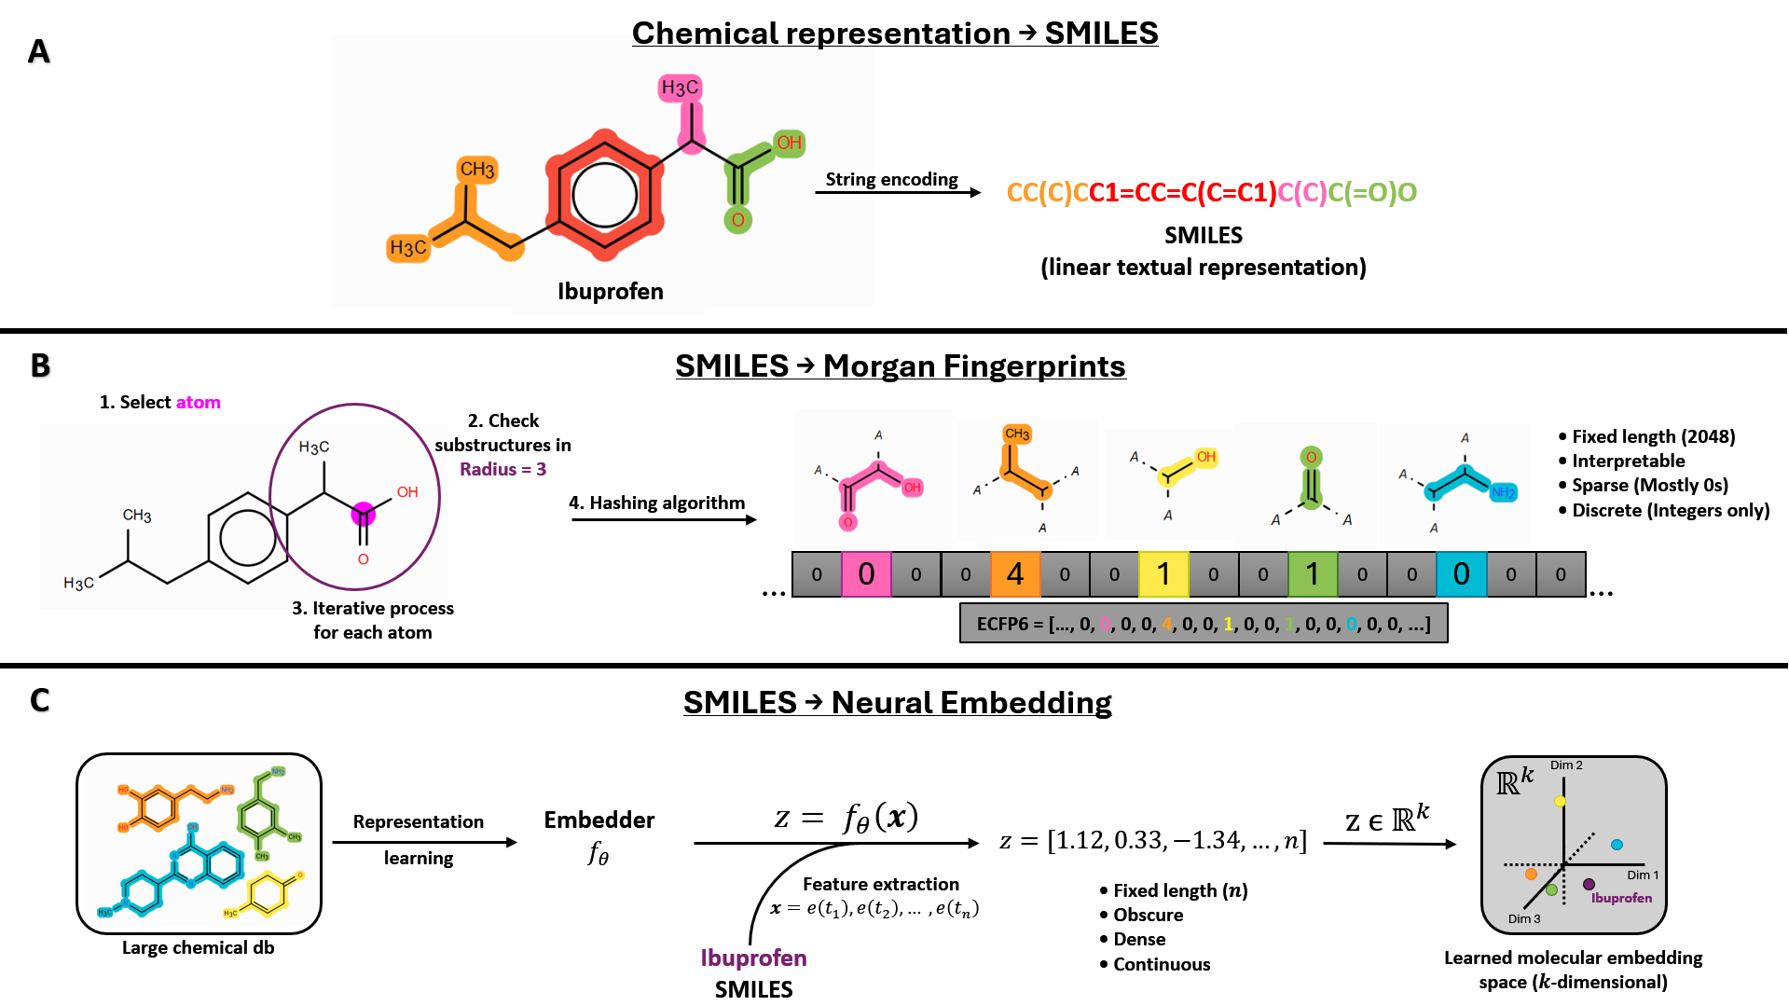
Figure 2. Schema of molecular representation pipelines. Source: Original artwork by the author.
(A) Example molecule (ibuprofen) and its SMILES encoding.
(B) Illustration of ECFP6 generation, where circular substructures (radius = 3) are enumerated and hashed into a fixed-length vector. This results in a sparse, discrete representation capturing predefined molecular fragments.
(C) Learned molecular embedding approach. A molecular encoder $f_{θ}$ is trained on a large chemical database through a general representation learning process. Given a new molecule (e.g., ibuprofen), its SMILES string is tokenized and converted into a sequence of embeddings $x=(e(t_{1}),e(t_{2}),…,e(t_{n}))$, which is then processed by the encoder to produce a continuous vector $z=f_{θ}(x)∈R^{k}$. This vector defines the position of the molecule within a learned $k$-dimensional latent space, where proximity between points reflects similarity in the encoded molecular features.
Binary fingerprints, and to a lesser extent count-based variants, represent molecules as collections of predefined substructures. While this strategy has proven highly effective in many QSAR applications, it ultimately reduces chemical space to a catalogue of fragments, potentially overlooking more subtle steric, electronic, or conformational effects that may influence enzymatic recognition. In the context of CYP450 metabolism, where substrate specificity depends not only on the presence of functional groups but also on their accessibility and surrounding environment, such simplification may limit the expressiveness of purely fragment-based descriptors.
Learned embeddings attempt to address this limitation by mapping molecules into dense continuous vector spaces, where structural similarity is inferred from patterns learned across large chemical corpora rather than from explicit substructure overlap. In principle, this allows chemically related molecules to occupy nearby regions in embedding space even when they do not share identical hashed fragments. However, the advantages of this approach are closely tied to data scale and model capacity; without sufficient training data, high-dimensional embeddings may fail to generalize and can underperform simpler, handcrafted representations.
Within embedding methodologies, an important distinction arises between static and contextualized representations. Static embeddings assign a fixed vector to each molecular fragment or token, meaning that a given substructure is represented identically regardless of its chemical environment. Among the available approaches, two representative models were selected, MolE and ChemBERTa. MolE (version 1), when used as frozen encoders, generate a single holistic embedding for the entire molecule based on patterns learned during large-scale pretraining. In contrast, transformer-based models such as ChemBERTa (ChemBERTa-zinc-base-v1) produce contextualized token embeddings: each atom or symbol in a SMILES string is encoded in relation to the full molecular sequence, allowing its representation to vary depending on neighbouring atoms and overall structure. This distinction is particularly relevant for metabolic prediction, as enzymatic activity is not determined solely by the presence of reactive groups but also by their steric accessibility, electronic modulation, and broader molecular context.
To ensure a fair comparison between molecular representations, all downstream models were evaluated under an identical benchmark framework using frozen multilabel-stratified train/test partitions and cross-validation folds. Three supervised learning approaches were considered: Logistic Regression (LR) as a linear baseline, Random Forest (RF) as a classical ensemble-tree method, and Extreme Gradient Boosting (XGBoost) as the primary gradient-boosting framework. In addition, a majority-class baseline predictor was included to establish a minimal reference level of performance. For every representation-model combination, hyperparameters were optimized via grid search exclusively on the training data, while prediction thresholds were selected independently for each CYP isoform during cross-validation. Final performance was assessed on a held-out test set using the same evaluation metrics throughout the study, namely macro-averaged Matthews Correlation Coefficient (MCC) as the principal metric, together with Micro-F1 and Hamming Loss as complementary measures of multilabel prediction quality.
By evaluating both MolE and ChemBERTa alongside Morgan fingerprints, this work attempts to assess whether increasingly expressive representation strategies translate into improved predictive performance for CYP450 metabolism.

Pre-training an InChI-Based Molecular Language Model for Feature Extraction (Complementary Experiment)
To complement the SMILES-based embeddings from MolE and ChemBERTa, a transformer-based masked language model (MLM) was pre-trained on 1.5 million InChI strings. This InChI-native encoder allows a controlled comparison of whether canonical, non-SMILES representations provide distinct or complementary signal for CYP450 prediction.

Motivation and Experimental Rationale
Most contemporary molecular language models, including MolE and ChemBERTa, operate exclusively on SMILES strings as their textual representation of chemical structure. As previously discussed, while SMILES is practical and widely adopted, it is not a canonical encoding by default and can admit multiple valid strings for the same molecule. In contrast, InChI provides a standardized, hierarchical, and deterministic representation designed to uniquely describe molecular connectivity and, most importantly, stereochemistry.
This experiment was therefore conceived as a complementary and tightly scoped experiment, was therefore to explore whether a transformer-based language model pretrained directly on InChI strings could learn meaningful structural representations that are usable for downstream CYP450 prediction. Given the relatively small size of the curated DrugBank dataset (~1.3k compounds), it is unlikely that a self-trained embedder would systematically outperform established fingerprints or large-scale pretrained models. However, evaluating an InChI-native encoder provides a principled way to examine whether non-SMILES textual encodings can capture alternative structural signals, such as the spatial arrangement of functional groups and stereochemical configurations, that are essential for enzyme-substrate interactions
Accordingly, this component is positioned as an exploratory extension that complements the primary internal benchmark, while contributing to the broader discussion on representation choice (SMILES vs. InChI) in cheminformatics-based learning systems.

Model Architecture & Training Setup
A transformer-based MLM was trained from scratch on InChI strings following a RoBERTa-style architecture [17], [18]. The training was purely self-supervised reconstructing randomly masked tokens within each InChI sequence. No metabolic annotations or downstream labels were used at this stage. This ensures that the learned representations encode general structural regularities of chemical compounds rather than task-specific information related to CYP450 metabolism.
Prior to model training, a custom tokenizer was built using a Byte-Pair Encoding (BPE) strategy [19]. A BPE approach was selected to avoid manually defining chemistry-specific token rules and to allow the tokenizer to automatically learn recurring structural patterns within InChI strings (e.g., connectivity blocks, InChI-specific syntax, layer separators) [20]. Given the relatively constrained alphabet and syntax of InChI representations, the vocabulary size was fixed at 2,000 tokens, which felt like a safe choice without extending it unnecessarily. A minimum token frequency of 2 was imposed to filter out spurious fragments generated by rare character combinations.
Sequences were truncated to a maximum length of 512 tokens to ensure stable training and compatibility with GPU memory constraints. Dynamic padding was enabled at batch level to avoid excessive memory usage while maintaining computational efficiency. These decisions were primarily pragmatic, as early runs revealed instability and memory limitations when allowing unbounded sequence lengths. This saved memory and made training feasible.
The transformer encoder was configured as a compact yet expressive model, with 6 hidden layers, a hidden size of 384, and 6 attention heads. This configuration provides sufficient representational capacity for learning structural dependencies in InChI sequences while remaining computationally tractable under the author’s limited hardware resources (4GB VRAM). The masked language modelling probability was set to 15%, following standard practice in transformer pretraining [17]. Training was conducted for three epochs using mixed precision (fp16) to improve efficiency, with gradient accumulation to achieve a stable effective batch size. A cosine learning rate scheduler and weight decay were applied to stabilize optimization [21].
The architectural scale and number of training epochs were not selected to maximize language modelling performance, but to obtain a structurally meaningful encoder within the practical time and hardware constraints of the project. Consequently, this model should be interpreted as a lightweight, domain-specific pretraining experiment rather than a large-scale foundation model comparable to industrial pretrained systems.

Positioning & Limitations
The architectural configuration of the InChI language model was primarily determined by computational constraints. The model was intentionally designed as a compact transformer (6 layers, hidden size 384, 6 attention heads) to remain computationally feasible under limited hardware resources. In contrast, large pretrained models such as ChemBERTa typically employ substantially larger hidden dimensions, deeper stacks, and are trained on tens of millions of molecules [12]. A direct performance comparison between this lightweight, domain-specific pretraining experiment and large-scale industrial or academic foundation models would therefore be inherently unfair. The present model was not optimized through extensive hyperparameter exploration nor scaled following established transformer scaling practices; rather, it was configured to obtain a stable and interpretable encoder within the time and resource boundaries of a master’s thesis project.
To accommodate GPU memory limitations, gradient accumulation was employed to simulate a larger effective batch size while maintaining small per-device batches. This is a standard technique in deep learning practice [22]. This approach reduces the variance of gradient estimates relative to very small batches, at the cost of less frequent parameter updates. Similarly, mixed-precision training (16-bit floating point) was enabled to reduce memory footprint and accelerate computation [23]. Although widely adopted in transformer training, reduced-precision arithmetic introduces minor numerical approximations compared to full 32-bit computation.
Tokenizer and sequence-length decisions also introduce assumptions. All sequences were truncated to a maximum of 512 tokens, and dynamic batch padding was applied to optimize memory usage. This implies that very long InChI strings, potentially those corresponding to large molecules or compounds with complex stereochemical layers, lose information beyond position 512. Implicitly, the model assumes that the initial portion of the InChI string contains sufficient structural information to capture features relevant for CYP450 metabolism, although this may have theoretical caveats. For most drug-like small molecules, this is a reasonable working assumption, as their InChI representations rarely approach extreme lengths. Nevertheless, this truncation constitutes a structural limitation of the representation and may disproportionately affect unusually large or complex compounds.
More broadly, this experiment does not attempt to claim architectural optimality. Decisions regarding vocabulary size, layer depth, hidden dimensionality, masking strategy, and scheduler configuration were guided by established transformer practices and empirical stability, but not by exhaustive ablation studies. Exploring alternative scaling regimes, tokenizer granularities, or architectural variants would require substantially larger computational resources. Consequently, the InChI encoder should be interpreted as an exploratory representation study rather than a definitive benchmark against state-of-the-art pretrained molecular language models.

Predictive Modelling Framework

Problem definition: Multi-label classification
Predictions of CYP450 metabolism are considered a multi-label classification problem, in which each molecule may be associated with zero, one, or multiple enzymes simultaneously. Unlike traditional single-label classification, where each instance is assigned to exactly one category, multi-label settings require the model to learn non-mutually exclusive relationships between input features and a set of target labels, CYP450 enzymes in our case.
Formally, given a dataset of molecular $X ∈ R^{n × d}$, the objective is to learn a mapping to a label matrix $Y ∈ {\left\{0, 1\right\}}^{n × k}$ where k denotes the number of CYP isoforms considered, XX in our case after removing low frequency isoforms. Each row of Y encodes a binary vector indicating the presence or absence of metabolism by each enzyme. From a ML perspective, a key challenge arises: label imbalance.
In our dataset, the distribution of CYP isoforms is highly skewed. A small number of enzymes, such as CYP3A4, dominate the dataset, while others appear much less frequently. This long-tail distribution leads to a scenario where standard learners tend to prioritise performance on frequent labels at the expense of rare but biologically important ones. As a result, naïve optimization strategies can produce models that at first glance appear competitive while failing to capture meaningful signals for infrequent enzymes. This issue is well-documented in multi-label learning literature, where imbalance has been shown to significantly degrade classifier performance, particularly for minority labels. [24]
From a modelling perspective, the task can be interpreted as learning a set of decision boundaries in a high-dimensional space, where each boundary corresponds to the likelihood that a molecule is metabolized by a given enzyme. In this work, we train a separate binary classifier for each CYP enzyme, treating each as its own binary prediction problem. This strategy is widely used in cheminformatics due to its simplicity, scalability, and robustness, particularly when dataset size is limited. [25] Although this approach may ignore some complex phenomena, like inter-label dependencies, it allows for clear interpretability and avoids compounding errors across labels.
In the context of drug discovery, the ideal model is one that considers the associate cost of bad predictions, especially considering the disproportionate cost of a false negative (FN) compared to a false positive (FP). Unlike many classification tasks where precision and recall are treated symmetrically, due to this imbalance, CYP prediction operates under asymmetric costs. A FN can have severe downstream consequences, including toxicity, drug–drug interactions, or late-stage clinical failure. Conversely, a FP, although costly due to additional experimental validation, does not inherently compromise safety or put in jeopardy the products development. This asymmetry implies that the model should favour sensitivity to true interactions even at the expense of a moderate increase in false positives, all while keeping an equilibrium between correct and incorrect predictions that can provide value to the investigators.

Algorithms evaluated
To evaluate the predictive value of the different molecular representations, several ML algorithms with progressively increasing modelling capacity were selected and assessed under the same validation framework. Rather than focusing on a single architecture, this benchmark was designed to compare how different classes of predictive models interact with fingerprint-based and embedding-based representations in the context of CYP450 metabolism prediction. The evaluated approaches range from a naïve majority baseline to linear and nonlinear ensemble methods, allowing both representation quality and model complexity to be analysed in a controlled and reproducible manner.

Majority Predictor
In the ‘majority_predictor.py’ file, a naïve majority-class baseline predictor was implemented to establish a minimal reference point for the benchmark. The model followed the same binary relevance formulation used throughout the study, treating each CYP isoform as an independent binary classification problem.
For every CYP, the predictor assigned to all molecules the most frequent class observed in the training set. Due to the class imbalance present in the dataset, this resulted in constant negative predictions for most isoforms, while CYP3A4 was consistently predicted as positive. No molecular descriptors or embeddings were used, as the baseline relied exclusively on class prevalence.

Although intentionally simplistic, this approach provides methodological context for interpreting the subsequent models. In highly imbalanced multilabel settings, trivial predictors may appear competitive under some metrics despite lacking any real discriminatory capability. Including this baseline therefore allows the performance of the supervised models to be evaluated against a clearly defined lower bound under the same train/test partitions and evaluation framework.

Logistic Regression
LR was selected as the primary linear baseline for the benchmark due to its widespread use in cheminformatics and its strong performance on sparse molecular descriptors, such as ECFP6. Unlike the majority predictor, LR incorporates molecular features directly into the decision process by learning a weighted linear combination of input variables associated with the probability of a molecule belonging to a given class.
For each CYP isoform, the model estimated the probability of metabolism through the logistic function:
$$P(y=1|x)= \frac{1}{1+ e^{-(ω^{T}x+b)}}$$
where $x$ is the molecular feature vector (e.g., ECFP6 counts), $ω$ the learned feature weights, and $b$ the intercept term. The expression $ω^{T}x$ denotes the dot product $\sum_{j}{ω_{j}x_{j}}$ , which combines the features linearly. The logistic function then maps the linear score $z= ω^{T}x+b$ to a probability between 0 and 1, producing an S‑shaped curve (FIGURE). A score of zero gives a probability of 0.5 while large positive scores approach 1, and large negative scores approach 0.
The resulting probability was later converted into a binary prediction through a decision threshold (τ): the molecule is predicted to be metabolised if $P(y=1|x) ≥ τ$. Instead of using a fixed threshold (e.g., 0.5), we optimise τ independently for each CYP during cross-validation to maximise the validation MCC.
[Placeholder for figure illustrating the sigmoid/logistic function and probability thresholding. – EXPLICR COMO VARIA LA CURVA CON DIFERENTES TH]
LR has historically shown competitive performance in QSAR and molecular property prediction tasks involving fingerprint representations, particularly when dataset sizes are moderate and descriptor spaces are highly sparse and high-dimensional. [26] Morgan fingerprints are especially well suited for this type of model because each bit or count corresponds to the presence of specific local substructures, allowing the classifier to assign interpretable positive or negative weights to chemically relevant fragments. [15] Previous benchmarking studies in cheminformatics have consistently reported Logistic Regression as a robust baseline for fingerprint-based molecular classification tasks, often remaining competitive against more complex methods on medium-sized datasets. [27] Nevertheless, in some cases LR has been observed to be more prone to overfitting than some alternative ML approaches, particularly when applied to high-dimensional molecular descriptors. [26] Despite this limitation, the method remained a competitive baseline across multiple benchmark datasets and was therefore included in the present study as a representative linear classifier.

The implementation followed the same binary relevance strategy used throughout the study, training one independent classifier per CYP isoform under identical train/test partitions and cross-validation folds. This strategy simplifies the modelling process while allowing each CYP to learn its own decision boundary and class distribution. To address class imbalance, all models used the parameter class_weight="balanced", which automatically adjusts class contributions inversely proportional to their observed frequencies in the training data.
A controlled hyperparameter grid search was then performed to identify suitable model configurations while maintaining a fair comparison with the remaining algorithms evaluated in this work. The hyperparameters explored for Logistic Regression are summarized in Table 1.
Table 1 Hyperparameter search space evaluated for Logistic Regression
Hyperparameter | Values explored | Description
C | 0.01, 0.1, 1.0, 10.0 | Inverse regularization strength. Smaller values impose stronger regularization, reducing coefficient magnitude and helping prevent overfitting.
penalty | L1 (Lasso), L2 (Ridge) | Type of regularization applied to model coefficients.
solver | liblinear, saga | Numerical optimization algorithm used to estimate model parameters.
max_iter | 5000 | Maximum number of optimization iterations allowed before stopping.

The explored values were selected to cover a moderate range of regularization strengths commonly used in cheminformatics classification tasks without introducing excessively large search spaces that could favour this model unfairly relative to the other benchmarked approaches. In particular, very large C values were avoided because they substantially reduce regularization and may lead to data overfitting.
Two regularization schemes were evaluated. L1 (Lasso) regularization promotes sparsity by driving less informative coefficients toward zero, effectively performing an implicit feature selection step. [28] This behaviour is particularly relevant for fingerprint representations, where thousands of sparse features may be present simultaneously. In contrast, L2 (Ridge) regularization distributes penalties more smoothly across coefficients, generally producing more stable solutions when many correlated features coexist. [29]
Regarding solver selection, preliminary experiments showed that the lbfgs solver frequently failed to converge for several CYP-specific models, even after substantially increasing the maximum number of iterations up to 10,000. In practical terms, convergence refers to the optimization process reaching a stable solution where further iterations no longer meaningfully improve the model parameters. Failure to converge indicates that the algorithm was unable to reliably identify such a stable optimum under the imposed iteration limits. Additionally, lbfgs does not support L1 regularization, which further limited its suitability for the present benchmark. Consequently, the liblinear and saga solvers were selected, as both are compatible with sparse high-dimensional data and support the regularization schemes evaluated in this study.

Random Forest
RF was selected as the principal classical ensemble-learning baseline in this study. Unlike LR, which learns a single linear decision boundary, RF combines the predictions of many decision trees, allowing it to capture complex and potentially nonlinear relationships between molecular features and metabolic activity. This characteristic has made RF one of the most widely used algorithms in QSAR modelling and molecular property prediction, where structure-activity relationships are often driven by interactions between multiple molecular descriptors rather than by individual features in isolation.
The algorithm constructs multiple decision trees from randomly sampled subsets of both molecules and features. Each tree independently learns a series of decision rules that partition the chemical space according to the molecular representation provided. For classification tasks, the final prediction is obtained by aggregating the predictions of all trees in the ensemble, this is, the fraction of trees in the ensemble that vote for the positive class. This combination of bootstrap sampling and feature randomization reduces variance and improves generalisation. [30]
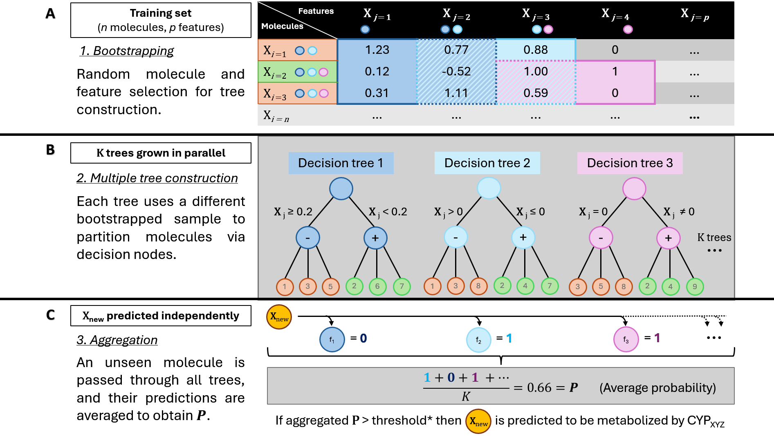
Figure 3 Schematic representation of the RF classification process. *Threshold optimised during cross-validation per CYP.
(A) Starting from the training dataset composed of n molecules and p molecular features, bootstrap samples are generated by randomly selecting molecules with replacement. During tree construction, random subsets of features are considered at each split, increasing diversity among trees. Coloured circles illustrate repeated sampling of molecules into different bootstrap datasets.
(B) Multiple decision trees are grown independently from the bootstrapped datasets. Each tree partitions the molecular feature space through a series of decision nodes based on different subsets of molecular descriptors, producing individual predictions for the target CYP isoform. Only three representative trees are shown for clarity, although the final model consists of a larger ensemble (K trees).
(C) For an unseen molecule X_{new}, predictions from all trees are aggregated to obtain a final class probability P. The probability corresponds to the proportion of trees predicting the positive class and is subsequently compared against a predefined decision threshold to determine whether the molecule is predicted to be metabolized by the CYP isoform under consideration.
RF has been extensively applied in cheminformatics and is frequently reported as a strong baseline for molecular classification tasks due to its ability to model nonlinear relationships without requiring extensive feature engineering or feature scaling. This property makes it particularly suitable for fingerprint-based representations, where interactions between different structural fragments may contribute jointly to metabolic behaviour. [31] Furthermore, RF can naturally handle both sparse count-based descriptors and dense embedding vectors, making it well suited for the comparative benchmark performed in this work. [26]
As in the LR implementation, a binary relevance strategy was adopted. A separate RF classifier was trained for each CYP isoform, allowing each enzyme to learn its own class distribution and decision boundaries independently. All models were trained and evaluated using the same fixed train/test partition and the same cross-validation folds employed throughout the benchmark. To account for class imbalance, the parameter class_weight="balanced" was applied to all models, increasing the influence of minority-class observations during tree construction.
Model selection was performed through an exhaustive grid search using the training set only. For each hyperparameter combination, a RF model was trained for every CYP isoform and evaluated across the predefined cross-validation folds. As with the other algorithms, probability thresholds were optimized independently for each CYP by maximizing the average validation MCC over the set of candidate thresholds. The best global hyperparameter configuration was then selected according to the highest average macro-MCC across all CYPs, with ties resolved in favour of the configuration showing lower variance between isoforms. This procedure ensured that model selection remained consistent with the evaluation framework used throughout the study.
The explored hyperparameters are summarized in Table 2.
Table 2 Hyperparameter search space evaluated for RF
Hyperparameter | Values explored | Description
n_estimators | 200, 300 | Number of decision trees in the ensemble.
max_depth | 12, 20 | Maximum depth allowed for each decision tree.
min_samples_split | 3, 5 | Minimum number of samples required to split an internal node.
max_features | sqrt, log2 | Number of features considered when searching for the best split at each node.

The selected search space was designed to balance model flexibility and computational cost while reducing the risk of excessive overfitting. The number of trees was limited to values commonly reported in molecular property prediction studies, where performance gains tend to plateau beyond a few hundred trees while computational requirements continue to increase. Tree depth was restricted to moderate values rather than allowing unrestricted growth, as very deep trees can memorize training observations and are particularly susceptible to overfitting in smaller datasets and less frequent CYP classes. Similarly, the min_samples_split parameter was included to prevent overly specific decision rules from being generated from only a handful of training examples.
The max_features parameter controls the degree of randomness introduced during tree construction. Evaluating both the square-root and logarithmic strategies allowed the benchmark to compare two commonly used approaches for reducing correlation between trees while maintaining sufficient diversity within the ensemble. Together, these hyperparameters govern the balance between model complexity, robustness, and generalization ability, making them the most influential variables in RF performance for the present application.

XGBoost
XGBoost was selected as the primary ML algorithm for this benchmark due to its strong performance on structured data and its widespread adoption in cheminformatics and bioinformatics applications. [26], [31] Unlike RF, which constructs multiple decision trees independently and combines their predictions through bagging, XGBoost builds trees sequentially. Each new tree is trained to correct the residual errors made by the existing ensemble, progressively improving the overall predictive performance. This sequential learning strategy allows the model to capture complex nonlinear relationships while maintaining a relatively compact architecture. [32]

[Figure X: Comparison between Random Forest and XGBoost. Random Forest builds trees independently and aggregates their predictions, whereas XGBoost constructs trees sequentially, with each tree learning from the errors of the previous ensemble.]

From a mathematical perspective, XGBoost minimizes an objective function composed of a prediction loss term and a regularization component:
$$L= \sum_{i}{l\left(y_{i}, {\hat{y}}_{i}\right)+ }\sum_{k}{Ω\left(f_{k}\right)}$$
where $l$ represents the logistic loss used for binary classification, and $Ω\left(f_{k}\right)$ penalizes the complexity of each decision tree by accounting for number of leaves in the tree and its weights. This regularization mechanism helps to reduce overfitting by penalizing non-efficient complexity while retaining the ability to learn complex useful decision boundaries. [32]
Like RF, XGBoost can naturally process sparse count-based molecular descriptors such as Morgan fingerprints without requiring feature scaling or normalization. The algorithm can also be applied directly to dense embedding vectors like those generated by ChemBERTa, MolE or the author-made InChI encoder. Since tree-based methods partition the feature space through threshold-based decisions rather than distance calculations, they are generally less sensitive to differences in feature scale than many linear or distance-based methods. This makes XGBoost particularly suitable for a comparable benchmark involving different molecular representations.
As before, a binary relevance framework was adopted, training one independent XGBoost classifier for each CYP isoform, maintaining therefore a consistent modelling strategy across all evaluated algorithms. The same frozen train/test partition and the same cross-validation folds were used throughout the benchmark to ensure comparability of results.
To address class imbalance, the parameter scale_pos_weight was computed independently for each CYP using the ratio between negative and positive examples present in the training set:
$$scale_pos_weight=\frac{N_{positive}}{N_{negative}}$$
This weighting scheme increases the contribution of minority-class observations during training without requiring any modification to the underlying data distribution.
Model selection was performed through a grid search procedure comparable to those used for the other algorithms, over a restricted set of hyperparameters chosen to balance model flexibility and generalization. The explored search space is summarized in Table 3.
Table 3. Hyperparameter search space evaluated for XGBoost
Hyperparameter | Values explored | Description
learning_rate | 0.05, 0.10, 0.20 | Shrinks the contribution of each tree added to the ensemble. Lower values generally improve generalization but require more boosting rounds.
max_depth | 6, 9 | Maximum depth of individual trees. Controls model complexity and the order of feature interactions that can be learned.
n_estimators | 100, 200, 300 | Number of boosting iterations (trees) in the ensemble.
scale_pos_weight | Calculated per CYP | Ratio of negative to positive training samples used to address class imbalance.

The selected ranges were intentionally conservative given the relatively limited size of the dataset. Very deep trees can memorize training examples and lead to unstable models, particularly for the less frequent CYP isoforms. For this reason, tree depth was restricted to a maximum of nine levels. Similarly, learning rates below 0.05 were not explored because they typically require substantially larger numbers of trees to achieve comparable performance, increasing both computational cost and the risk of fitting noise in small datasets. The chosen search space therefore reflects a compromise between model expressiveness and robustness.
As with the LR and RF implementations, hyperparameter selection was integrated with threshold optimization. For each CYP and each hyperparameter combination, the decision threshold was optimized during cross-validation by maximizing the average validation MCC across the candidate thresholds. Once the optimal threshold had been identified for every CYP, the average macro-MCC across all isoforms was used to select the best global hyperparameter configuration.
Following model selection, a final XGBoost classifier was retrained for each CYP using the complete training set and the selected hyperparameters. The corresponding optimal thresholds were retained and subsequently applied to the independent test set to obtain the final predictions and evaluation metrics. This procedure ensured that all model selection decisions remained confined to the training data, preventing information leakage from the test set.
Compared with RF, XGBoost is expected to benefit from its sequential error-correction mechanism and explicit regularization framework, which can often achieve similar or superior predictive performance using fewer trees. The ability to iteratively focus on difficult training examples may be particularly advantageous when modelling subtle structure-metabolism relationships that are not captured by individual trees alone. Nevertheless, boosting methods are also known to be more sensitive to hyperparameter selection and can overfit small datasets if model complexity is not appropriately constrained. The restricted search space and cross-validation strategy adopted in this work were therefore intended to balance predictive performance with generalization ability.
All models were implemented using the XGBoost Python library and trained with n_jobs=1 to ensure deterministic and fully reproducible execution. Furthermore, the same train/test partitions, cross-validation folds, threshold optimization procedure, and evaluation metrics were used across all molecular representations and learning algorithms, ensuring that performance differences could be attributed to the representation and modelling choices rather than to variations in the experimental setup.

Model evaluation
A rigorous evaluation framework is essential for comparing molecular representations and for diagnosing model behaviour across CYP isoforms with widely different frequencies. Given the multi-label nature of the task and the severe imbalance between common and rare enzymes, standard classification metrics such as accuracy or per-class precision are insufficient. This insufficiency is not merely a statistical technicality but reflects a crucial practical consideration in drug discovery. In early-stage development, the cost of a false negative, this is, failing to predict that a compound interacts with a CYP enzyme when it actually does, is substantially higher than that of a false positive. A missed interaction can allow a problematic compound to advance through costly development, potentially leading to clinical trial failures due to unexpected toxicity or dangerous drug-drug interactions, or even post-market withdrawal. [2] The pharmaceutical industry has long recognised this challenge, with conventional prediction methods being wrong approximately one third of the time, resulting in millions of dollars and years of effort going to waste. [33] Consequently, accuracy would be dangerously misleading in this domain. A predictor that always returns negative would achieve high accuracy on rare CYPs simply because positive cases are so few, yet such a predictor would be useless in practice. For these reasons, a suite of more complete and appropriate metrics was selected to evaluate model performance and enable meaningful comparability across representations.

Primary Metric: Mean Matthews Correlation Coefficient (Macro MCC)
The MCC measures the quality of binary classifications by taking into account all four entries of the confusion matrix: true positives (TP), true negatives (TN), FP and FN. For a single CYP isoform, MCC is defined as
​$MCC= \frac{TP × TN - FP × FN}{\sqrt{\left(TP+TN\right)(TP+FN)(TN+FP)(TN+FN)}}$
and ranges from –1 (complete disagreement) through 0 (no better than random) to +1 (perfect prediction). Because MCC incorporates true negatives, it remains informative even when the positive class is rare, a regime where metrics based solely on precision and recall (like F1) can become unstable or misleading. [34], [35]
To obtain a single performance score across all CYP isoforms, the per-enzyme MCC values are averaged. The resulting quantity, referred to as the macro MCC treats each CYP enzyme equally regardless of how many molecules are substrates of that enzyme. This ensures that excellent performance on a highly frequent isoform such as CYP3A4 does not mask poor performance on a rarer isoform such as CYP2A6. Macro MCC serves as the primary metric for two critical tasks: comparing molecular representations (ECFP6, MolE, ChemBERTa, and the exploratory InChI encoder) and selecting hyperparameters. During cross-validation (CV) on the development set, hyperparameter configurations are chosen based on the macro MCC averaged over validation folds, guaranteeing that tuning benefits all CYP isoforms jointly rather than favouring majority classes.

Secondary Metric: Micro-F1
While mean MCC provides a balanced view across enzymes, it is also useful to assess performance at the level of individual predictions. Micro-F1 aggregates all TP, FP and FN across all CYP isoforms and all test molecules before computing a single F1 score:
$$Micro F1=\frac{2 × \sum{TP}}{2 × \sum{TP}+ \sum{FP}+ \sum{FN} }$$
Micro-F1 is dominated by the most frequent enzymes because they contribute the largest number of predictions. It answers a complementary question to mean MCC, namely how well the model performs on the typical prediction task weighted by how often each CYP appears. Micro-F1 is reported as a secondary metric in the main comparison table. It is not used for hyperparameter optimisation or for ranking representations, but it helps characterise model behaviour from a per-prediction perspective.

Complementary Metric: Hamming Loss
Hamming Loss (HL) measures the fraction of incorrect predictions out of the total number of molecule-CYP pairs:
$$Hamming Loss= \frac{1}{N×L}\sum_{j=1}^{N}{\sum_{k=1}^{L}{[y_{jk}≠{\hat{y}}_{jk}]}}$$
where N is the number of test molecules, L the number of CYP isoforms, and the Iverson brackets, counts the number of positions where the true label $y_{jk}$ differs from the predicted label ${\hat{y}}_{jk}$. HL ranges from 0 (perfect) to 1 (completely wrong) and is straightforward to interpret. It is included as an informative metric only, providing a high-level summary of overall prediction quality. Because HL does not distinguish between false positives and false negatives nor account for class imbalance, it is not used for model comparison or hyperparameter tuning. Instead, it appears alongside the primary and secondary metrics to offer a complete yet concise picture of model performance. [36]

Diagnostic Metric: Variance of MCC Across CYP Isoforms
Beyond comparing representations, it is valuable to understand whether a model performs consistently across common and rare enzymes. For each representation, the variance (or standard deviation) of per-CYP MCC values is computed. Low variance indicates that the model achieves similar predictive quality regardless of CYP frequency, implying that data scarcity is not the sole limiting factor. High variance, by contrast, suggests that performance is uneven, with excellent predictions on some CYPs but poor predictions on others, pointing to a need for more balanced training data or specialised techniques. MCC variance is used as a diagnostic metric exclusively in the discussion section, helping to interpret why certain representations may appear superior in mean MCC while failing on specific isoforms and informing the final conclusions about the practical utility of each representation for early drug discovery.

Behaviour Under Extreme Imbalance
When a CYP isoform has very few positive samples in the test set, metrics that ignore true negatives, such as F1 or precision, can become highly unstable, varying drastically with a handful of correct or incorrect predictions. Macro MCC, by incorporating true negatives, remains mathematically well-defined and provides a more stable estimate of true predictive quality. Micro-F1, being dominated by frequent classes, is largely unaffected by the performance on rare CYPs, which is simultaneously its strength, providing a stable global estimate, and its limitation, being insensitive to rare-class failures. HL also remains stable, but because it aggregates all errors, it cannot reveal whether poor performance originates on rare or common enzymes. The combination of mean MCC for overall balanced performance and MCC variance for consistency across frequencies therefore offers the most informative and robust evaluation framework for this imbalanced multi-label task. [37]

Model Selection and Cross-Validation
To maximise the amount of data available for training while preserving an unbiased estimate of generalisation performance, an 80/20 stratified split is applied to the curated dataset. The larger portion, comprising 80% of the compounds, serves as the development set. The remaining 20% is held out as a test set and is used only once, after all model selection and hyperparameter tuning is complete, to report final performance. This strict separation prevents information leakage from the test set into the model development process.
Hyperparameter optimisation is conducted exclusively on the development set using three-fold CV The development set is partitioned into three disjoint folds of approximately equal size. For each hyperparameter configuration under consideration, a model is trained on two of the three folds and evaluated on the remaining fold. This process is repeated three times, rotating which fold serves as the validation set. The performance scores obtained from the three validation folds are averaged to produce a single CV score for that configuration. The hyperparameter combination that yields the highest mean MCC across the three folds is selected as optimal. This procedure is applied identically to each molecular representation and to each learning algorithm evaluated in the study.
CV is performed using the same development set splits across all hyperparameter configurations to ensure comparability. The selected hyperparameters are then used to retrain a final model on the full development set, from scratch and without any memory of the CV training cycles. This final model is subsequently evaluated once on the held-out test set using the metrics defined in the previous section.
This design offers several advantages given the limited size of the curated dataset. The 80/20 split reserves the majority of data for training and validation, which is particularly beneficial when the total number of labelled compounds is approximately 1,300. The use of three-fold CV on the development set reduces the variance of performance estimates compared to a single validation split, leading to more robust hyperparameter selection. At the same time, the strict separation of the test set guarantees that the reported final performance reflects true generalisation to unseen molecules, free from any data leakage.

RESULTS

Data Acquisition

InChI Database
To obtain cleaned InChIs ready to be used to train the self-developed embedder, a set of verified SMILES strings was obtained from a Kaggle dataset derived from ChEMBL [38]. The dataset contains approximately 1.5 million entries, each consisting of a SMILES string in the first column and a reference to the corresponding ChEMBL entry in the second.
These SMILES where converted to InChI using the RDKit library, which parses each SMILES string into an internal molecular representation and subsequently generates its corresponding standardized InChI string. The pipeline was executed in a sequential manner over the full dataset, producing a large corpus of InChI sequences to be used for tokenizer training and MLM model pretraining. Summary statistics of the conversion process, including throughput and success rate, are presented in Figure 3.
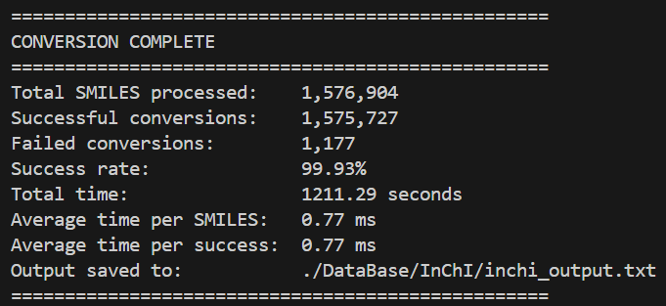
Figure 4. Summary statistics of the SMILES-to-InChI conversion process, including total processed molecules, number of successful and failed conversions, overall success rate, and execution time.

Metabolism-related Database
To obtain metabolism-related data associated with CYP450 enzymes in a structured format, an application was made to DrugBank, an online repository of pharmacological data. After approval for academic use, all their db were readily available, containing structural and pharmacological data of over 1300 small molecule drugs which will serve as backbone for the final data set.
The data obtained from several relational tables was combined to produce a pandas data frame (df) containing a primary key that will be the “DrugBank ID”, which is a unique identifier for each chemical compound. This df also contained the following data:
- “CYPs”: List of all the cytochromes that metabolize it.
- “InChI”
- “SMILES”
Only those drugs that were classified as “SmallMoleculeDrugs” were included in the final df, excluding those with the tag “BiotechDrug” which mostly include proteins and peptides, which are well known to be metabolized as normal proteins, not cytochromes. Any of these drugs tagged with any CYP450 was most likely due to inhibitory interactions not linked to metabolism.
Custom Python functions were developed to automate compound name searches and retrieve canonical SMILES strings. In some cases, the missing SMILES was found directly, while in other cases several different compounds were obtained with the same name. This was because the given name was one that encapsulated several compounds like for example “Omega-3-carboxylic acids”. In these cases, a fake unique “DrugBank ID” was given, and the new lines with the SMILES of each concrete chemical compound was added with the same CYPs as the parent compound. These SMILES representations were then converted into standardized InChI formats using RDKit, seamlessly enriching the dataset with essential molecular descriptors.
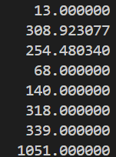
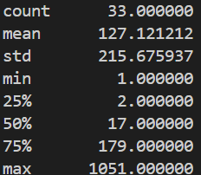
By using the ChemSpiPy API, 15 missing compounds’ SMILES/InChI were obtained, with 3 being flagged as duplicates (Vitamin E/Tocopherol, Cholecalciferol, and dihydroergocryptine) and removed. This gave a final db containing 1369 compounds. In the whole db, 33 different CYP450 isoenzymes were present with a mean appearance frequency of 127 compounds per CYP. The most common isoform, CYP3A4, appears in 1051 compounds while 20 isoforms appear in fewer than 50 compounds (Figure 4A). These low frequency CYP450s were removed from the db as they would not have enough true positives to train and test a model in a reliable and robust manner given the projected 80/20 data split used for training/testing of the models. This threshold of 50 was chosen to produce a test split with at least 10 positive compounds, allowing for a better evaluation of the model’s performance using the selected metrics, ensuring more stable metric readings. This left 13 unique high- to medium-frequency CYP450 with an improved mean of 308 compound appearances (Figure 4B).
A B
Figure 5. CYP450 ‘dict’ descriptors for full db (A) and curated db with threshold = 50 (B). Dict( CYP name : Nº of appearances )

Data source description
- DrugBank [39]: It is a freely accessible online db for academic use that provides comprehensive information on drugs and their molecular targets. It integrates bioinformatics and cheminformatics data, covering chemical, pharmacological, pharmaceutical properties as well as details on related proteins, sequences, structures, and biological pathways. Db downloaded on 28/08/2025.
- Kaggle: It is an open online platform dedicated to data science and ML that hosts publicly accessible datasets, predictive modelling competitions, and collaborative notebooks. Kaggle aggregates datasets contributed by both institutions and individual researchers, covering a wide range of domains including chemistry and bioinformatics. In this work, Kaggle served as the access point for acquiring a pre-processed dataset of drug-like compounds. Db downloaded on 18/02/2026.
- ChEMBL [40]: It is a manually curated, freely accessible database that provides comprehensive bioactivity data for drug-like compounds. It integrates chemical, biological, and pharmacological information, covering from compound structures to bioactivity measurements against biological targets. The data is primarily extracted from the primary medicinal chemistry literature. For this project, ChEMBL served as the fundamental source for the SMILES strings used to train the proprietary InChI embedder, providing the large-scale, high-quality structural data necessary for developing robust chemical representations.

Exploratory data analysis (EDA)
This section provides a structured overview of the data used throughout the project, focusing on its composition, underlying patterns, and potential limitations. The objective is to characterise both the molecular representations and the associated annotations in a way that supports informed decisions in the modelling pipeline, particularly in terms of representation choices, preprocessing steps, and evaluation design.

InChI Database EDA
The analysis of the InChI-based representation reveals several limitations that are important to contextualize the expected performance of the downstream models. These arise primarily from the characteristics of the source data and the constraints of the InChI representation itself, and are discussed here in terms of their practical implications.
A central limitation is the near-complete absence of stereochemical information in the dataset. Only 0.01% of the entries (93 molecules) contain stereochemical annotations in their InChI strings. This can be partially explained by the behaviour of the SMILES-to-InChI conversion process: the use of the \ character, required to encode trans (E) stereochemistry, leads to parsing issues and results in the loss of this information, while the absence of the @ symbol in the original SMILES dataset indicates that chiral centres (R/S stereochemistry) were not present in the original dataset in the first place. Even when considering the 0.07% of SMILES that failed conversion (1177 strings), and assuming in a worst-case scenario that all of them contained stereochemical information, the overall proportion would remain very low. This suggests that the scarcity of stereochemistry is largely a property of the source dataset rather than an artefact introduced during preprocessing. Nevertheless, this remains a relevant limitation, as CYP450-mediated metabolism can be stereoselective, and the model will not be able to accurately capture such effects.
The dataset also exhibits a moderate level of duplication, with approximately 4.7% of entries repeated. Nearly identical duplication rates were observed in the SMILES and InChI db. This indicates that redundancy is primarily inherited from the original database, with only a minor contribution from InChI canonicalization, where different but equivalent SMILES map to the same representation. Some of the most frequently repeated entries correspond to large, peptide-like structures, which likely arise from repeated records in the source data. Unfortunately, these repeated entries were not eliminated in what could have been an improvement of the workflow. However, these types of structures represent only a small fraction of the overall dataset. They are therefore unlikely to significantly influence or bias the model’s performance in a meaningful way. While duplication introduces a degree of frequency bias, where certain molecules are overrepresented, the magnitude of this effect is overall moderate and consistent with typical large-scale chemical databases.
The distribution of sequence lengths in the raw InChI representation shows a clear right-skew, with most molecules concentrated within a relatively narrow range and a long tail corresponding to increasingly complex structures (Figure 5).
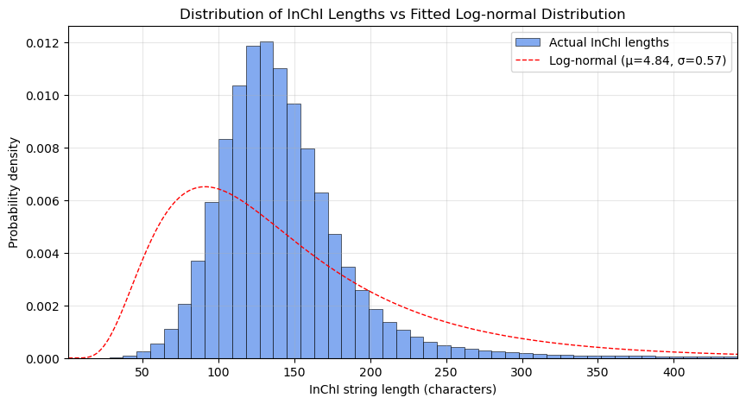
Figure 6 Distribution of InChI string lengths with fitted log-normal distribution. The histogram represents the empirical distribution, with the x-axis truncated at the 99th percentile to improve visual clarity by excluding extreme outliers. The dashed red line corresponds to a fitted log-normal distribution, shown for reference to illustrate the overall shape of the data.
A log-normal distribution provides a reasonable visual approximation of this behaviour, capturing the asymmetry and extended tail observed in the data. This is consistent with the progressive increase in structural complexity as molecules grow.
When applying tokenization, the same overall pattern is preserved, with the distribution maintaining its shape while being rescaled to shorter sequence lengths (Figure 6). This indicates that the transformation does not distort the underlying structural characteristics of the dataset.
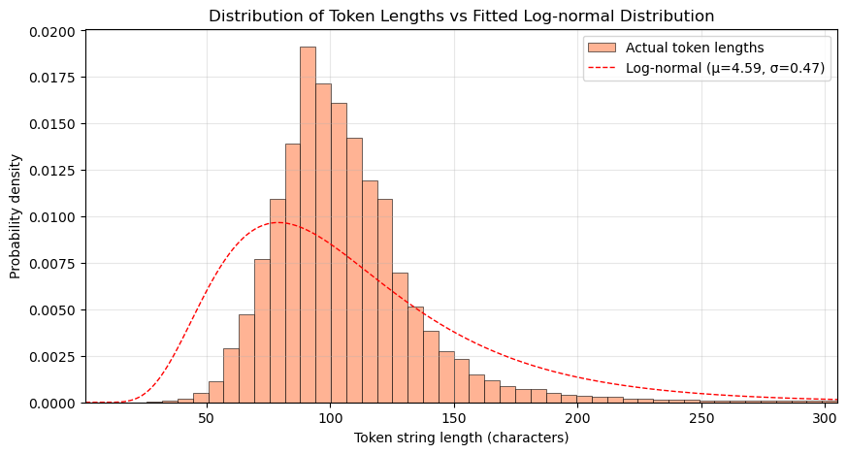
Figure 7 Distribution of tokenized InChI sequence lengths with fitted log-normal distribution. The x-axis is truncated at the 99th percentile for visual clarity. The fitted log-normal curve is shown for reference.
Based on the tokenized sequences, a maximum length of 512 tokens covers more than 99% of the dataset without truncation. The sequences exceeding this threshold correspond predominantly to very large, peptide-like molecules, which are less likely to be primarily metabolized by CYP450 enzymes and instead tend to undergo degradation via proteolytic pathways. As such, the truncation strategy represents a practical trade-off, preserving the vast majority of relevant small-molecule information while maintaining computational efficiency.
With respect to the tokenization process, it is important to note that the Byte-Pair Encoding (BPE) tokenizer learns statistical substructures rather than chemically meaningful units. As a result, individual tokens do not have a direct chemical interpretation. This is an inherent characteristic of data-driven representation learning approaches and is consistent with the broader use of such methods in ML, where predictive performance is typically prioritised over interpretability.
Finally, the scope of the representation is limited to molecules that can be reliably encoded as SMILES and converted into InChI format. Certain classes of compounds, such as metal complexes, are not well supported by this pipeline and are therefore not represented in the dataset. This work is intentionally focused on organic small molecules, which are the primary domain of CYP450-mediated metabolism, and thus this limitation does not significantly affect the applicability of the results within the intended scope.
Overall, the InChI representation is structurally consistent and efficiently tokenized, enabling its use in a ML context. The most relevant limitation is the lack of stereochemical information, which may restrict the model’s ability to capture certain metabolic effects. The dataset also contains moderate duplication and exhibits a long-tail distribution of molecular complexity, both of which are characteristic of real-world chemical databases and are appropriately managed within the pipeline. These factors are well understood and provide a clear context for interpreting the results of the modelling stage.

Metabolism-related Database EDA
Benchmark predictor: https://insilico-cyp.charite.de/SuperCYPsPred/index.php?site=Statistics

Data Preprocessing
This section describes the preprocessing of the curated DrugBank metabolism dataset (1,368 compounds), where molecular structures are encoded into numerical representations for ML. All feature matrices generated in the following subsections are derived from this same set of compounds.

Molecular Fingerprint Generation Using Morgan Algorithm
Firstly, molecular structures were encoded using Morgan fingerprints (ECFP6) derived from their canonical SMILES representations. These were computed using the cheminformatics toolkit RDKit.
Each SMILES string was first parsed into an internal molecular graph object. The Morgan algorithm then iteratively enumerates circular atom environments up to a predefined radius. In this implementation, a radius of 3 was selected, corresponding to ECFP6 (i.e., neighborhoods spanning up to 6 bonds) as previously discussed. These local atomic environments were hashed into fixed-length count vectors of 2,048 dimensions. After processing the curated dataset, this resulted in a fingerprint matrix:
$$X∈N_{0}^{1368×2048}$$
where 1,367 corresponds to the number of compounds in the final dataset and each of the 2,048 columns represents the count of a particular hashed substructure identified within a molecule.
In contrast to binary fingerprints, count-based fingerprints were intentionally selected in order to preserve the multiplicity of structural motifs. Since CYP450-mediated metabolism is often influenced by the frequency of specific functional groups or reactive moieties within a molecule, retaining substructure counts provides a richer representation than simple presence/absence encoding, while maintaining interpretability and computational efficiency.
The resulting fingerprint vectors were assembled into a tab-separated values (.tsv) file structured as a 1,368 × 2,048 numerical matrix. Each row was indexed by the corresponding DrugBank identifier, and columns were labelled from 0 to 2047 to represent individual hashed substructure bins. This structure allows direct compatibility with downstream supervised learning algorithms implemented in scikit-learn and related frameworks.
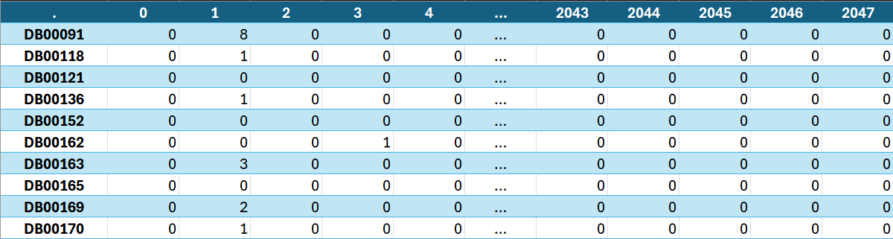
Figure 8. Morgan fingerprint feature matrix (ECFP6, radius = 3) for the curated dataset. Rows correspond to DrugBank IDs; columns represent hashed substructure counts. The resulting matrix has dimensions 1368 × 2048 and contains integer count values.

Molecular Embedding Extraction Using MolE
To complement the fingerprint-based molecular representation, pretrained molecular embeddings were generated using MolE (Molecular Embeddings) [41], an open-source framework designed to produce static vector representations from SMILES strings.
MolE was installed in an isolated virtual environment by following the official instructions provided in its public GitHub repository. The environment was configured locally using a standard Python setup. Although the repository provides GPU-enabled execution as the default configuration, the embedding extraction was performed using CPU-only computation to ensure compatibility with the available hardware.
After installation, a truncated copy of the DrugBank db containing columns ‘id’ and ‘SMILES’, was provided as input to the MolE pipeline. The framework tokenizes each SMILES string, processes it through a pretrained sequence model, and outputs a fixed-length latent representation for each molecule.
The script generated a .tsv file containing the static embeddings as a 1,368 × 1,000 table of float64 values, where each row corresponds to a molecule and each column to an embedding dimension (i.e., $Z∈R^{N×d}$, with $N=1,368$ and $d=1,000$).
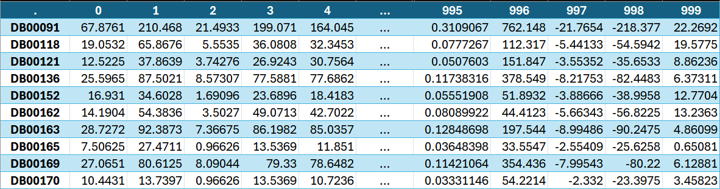
Figure 9. MolE embedding matrix for the curated dataset. Rows correspond to DrugBank IDs; columns represent pretrained embedding dimensions from the MolE transformer. The resulting matrix has dimensions 1368 × 1000 and contains continuous-valued vectors.

Molecular Embedding Extraction Using ChemBERTa
Another set of molecular embeddings were generated using ChemBERTa, a transformer-based language model pretrained on large corpora of SMILES strings. Unlike static fragment-based embeddings, ChemBERTa produces contextualized token representations, allowing the model to capture sequence-dependent chemical information.
The implementation was carried out using the HuggingFace transformers library. A pretrained ChemBERTa model and its associated tokenizer were loaded once at module initialization to ensure computational efficiency and deterministic inference. Each SMILES string was first tokenized into subword units compatible with the model’s vocabulary. To prevent truncation of unusually large molecules, the maximum token length was set to 1024, exceeding the default configuration and ensuring preservation of structural information for macrocyclic or highly complex compounds.
During inference, gradient computation was disabled and the model operated in evaluation mode. The output consists of contextualized token embeddings of dimension 768 for each position in the sequence. To obtain a single fixed-length molecular representation, mean pooling was applied across the token dimension, excluding padding tokens via the attention mask. This procedure yields one embedding vector per molecule.
After processing the curated dataset, the resulting embedding matrix was:
$$X∈R^{1368×768}$$
where 1,368 corresponds to the number of compounds in the final dataset and 768 represents the hidden dimensionality of the ChemBERTa model. The embeddings were exported as a .tsv file structured analogously to previous representations: rows indexed by DrugBank ID and columns labeled from 0 to 767, ensuring compatibility with downstream supervised learning pipelines.
To maintain consistency with MolE embeddings and facilitate concatenation or comparative experiments across learned representations, the output vectors were stored in float64 format.
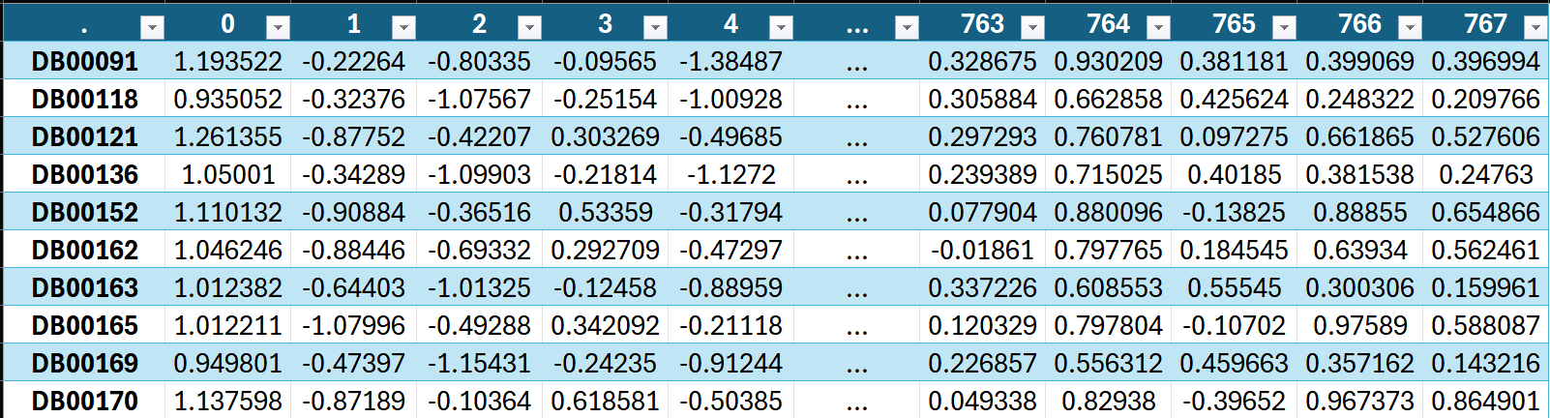
Figure 10. ChemBERTa embedding matrix for the curated dataset. Rows correspond to DrugBank IDs; columns represent pretrained embedding dimensions from the ChemBERTa transformer. The resulting matrix has dimensions 1368 × 768 and contains continuous-valued vectors.

Molecular Embedding Extraction Using Author-Trained InChI embedder
Following the pretraining procedure described in Section 7.3.1, the final InChI-based MLM was successfully trained and exported for downstream use as a feature extractor. The training process completed without instability, reaching convergence within the predefined three epochs under the constrained configuration. The final checkpoint was saved together with the learned tokenizer, enabling deterministic and reproducible embedding extraction.
From a practical standpoint, the most limiting factor during this stage was not model design but hardware capacity. Training was conducted on a laptop’s local GPU with 4GB of VRAM, which imposed strict constraints on batch size, sequence length, and overall architectural scale. Techniques such as mixed-precision training and gradient accumulation were necessary to make the process feasible, effectively trading off training speed for memory efficiency. Despite these optimizations, training remained time-consuming, requiring several hours per epoch and careful monitoring to avoid memory overflows.
In principle, this workload could have been significantly accelerated using cloud-based GPU instances, where access to higher-memory devices (e.g., 16–24GB VRAM) would allow larger batch sizes, longer sequences, and faster convergence. However, the decision was made to carry out the full training pipeline locally. This choice was motivated by considerations of reproducibility, cost control, and full independence of the experimental setup. By avoiding reliance on external infrastructure, the entire workflow, from data preprocessing to model training and embedding extraction, remains fully portable and reproducible on standard hardware.
Once trained, the model was used as a fixed feature extractor. Each molecule from the DrugBank database, represented as an InChI string, was tokenized using the learned Byte-Pair Encoding tokenizer and processed through the transformer encoder in inference mode. Consistent with the training configuration, sequences were truncated to a maximum length of 512 tokens to ensure compatibility with the learned positional embeddings.
The model produces a sequence of token-level embeddings of dimension 384 for each InChI string. To obtain a single representation per molecule, these token embeddings are averaged using mean pooling, considering only valid (non-padding) tokens. Formally:
$$h_{i}​=\frac{1}{T_{i}}\sum_{j=1}^{T_{i}}{e_{j}}​$$
where $e_{j}∈R^{384}$is the embedding of token $j$, and $T_{i}$is the number of valid tokens in molecule $i$. The resulting vector $h_{i}∈R^{384}$represents the molecule in the embedding space.
As with the other embedding methods, the resulting vectors were stored in float64 format and exported as a tab-separated values (.tsv) file, with rows indexed by DrugBank ID and columns labeled from 0 to 383. This ensures full compatibility with downstream ML pipelines and enables direct comparison with alternative representations.
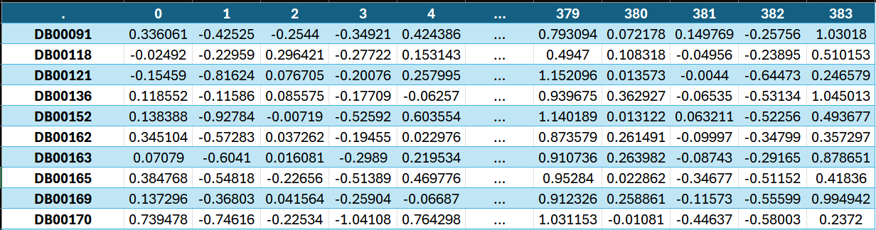
Figure 11. InChI-based embedding matrix for the curated dataset. Rows correspond to DrugBank IDs; columns represent embedding dimensions from the author-trained InChI transformer. The resulting matrix has dimensions 1368 × 384 and contains continuous-valued vectors.

Feature Selection
To ensure a fair and interpretable comparison between molecular representations, no explicit feature-selection procedure was applied prior to model training. All molecular descriptors generated during the representation stage were retained in their complete form and used directly as inputs to the predictive models. This decision was made to ensure that performance differences could be attributed primarily to the representations themselves rather than to additional feature-engineering choices.
Consequently, no filter-based methods (e.g., variance or correlation filtering) or dimensionality-reduction techniques such as Principal Component Analysis were employed. Likewise, no feature scaling or normalization was incorporated as part of the feature-selection stage, although it is important to note that some of the evaluated algorithms incorporate mechanisms that can implicitly reduce the influence of less informative variables during training. Specifically, LR may perform coefficient shrinkage through L1 (Lasso) and L2 (Ridge) regularization, but these processes occur as part of model fitting and were not considered a separate feature-selection stage within the benchmark. Meanwhile, RF and XGBoost naturally prioritize informative features when constructing decision trees but again, this is not considered a separate feature-selection stage per se.
For the Morgan fingerprint representation, all 2,048 count-based ECFP6 features were retained. Such sparse, high-dimensional descriptor spaces are routinely used in cheminformatics and can be handled directly by both linear and tree-based ML algorithms, so no specific feature selection mechanism was considered to be required.
For the embedding-based representations, the complete latent vectors produced by each encoder were preserved without modification. Unlike handcrafted fingerprints, these representations already constitute compressed feature spaces learned during pretraining so applying additional dimensionality reduction could inadvertently remove information already encoded by the embedding models hindering a fair assessment of their representational capacity.
Overall, all representation-model combinations were trained using the complete feature spaces generated during preprocessing. This approach ensured methodological consistency across the benchmark and allowed the comparison to focus on the predictive value of the molecular representations.

Data Splitting
To ensure a fair comparison between molecular representations and machine-learning algorithms, all experiments were conducted using a fixed benchmark partitioning strategy. Since the objective of this work was to evaluate the effect of different molecular representations and predictive models, it was essential that every experiment be trained and evaluated on exactly the same molecules. Consequently, the data splits were generated once and subsequently reused throughout the entire study.

The curated dataset was divided into an 80% training set and a 20% independent test set using iterative multilabel stratification through the `MultilabelStratifiedShuffleSplit` algorithm. Unlike conventional stratification methods, this approach attempts to preserve the distribution of all CYP labels simultaneously, which is particularly important in multi-label problems where a single molecule may be associated with multiple isoenzymes. The resulting test set remained completely isolated during model selection and hyperparameter optimisation and was only used for the final performance assessment.

Cross-validation was performed exclusively within the training partition. A three-fold iterative multilabel stratified scheme was generated using `MultilabelStratifiedKFold`, ensuring that each fold retained a label distribution similar to that of the complete training set. To improve the stability of the evaluation process, an additional validation step was incorporated during fold generation. Candidate random seeds were iteratively tested until every validation fold contained at least ten positive examples for each included CYP isoform. This threshold was selected to reduce the risk of highly unstable MCC estimates caused by extremely sparse validation subsets. Similarly, CYP classes with fewer than five positive examples in either the training or test partitions were excluded from the benchmark, as performance estimates based on such limited numbers become unreliable and difficult to interpret.

The split generation process used the Morgan fingerprint dataset as a reference because it contained the complete set of molecules included in the study. However, the resulting train/test partitions and cross-validation folds were defined exclusively by molecule identifiers and were therefore independent of any particular representation. The same partitions could consequently be applied without modification to the ECFP6 fingerprints, MolE embeddings, ChemBERTa embeddings, and the author-trained InChI embeddings.

Once generated, the train/test partitions, cross-validation folds, and list of included CYP isoforms were frozen and stored for subsequent reuse. All representation–model combinations, including the Majority Predictor, Logistic Regression, Random Forest, and XGBoost pipelines, loaded the same predefined molecule identifiers and fold assignments. This eliminated variability arising from repeated random partitioning and ensured that any observed differences in performance reflected the representations and learning algorithms themselves rather than differences in the underlying data splits.

To further support reproducibility, the splitting procedure was implemented as a dedicated and reusable component of the benchmark pipeline. The generated partitions were saved in the `benchmark_splits.joblib` file and subsequently loaded by all training scripts rather than being regenerated independently. A human-readable export of the same information is provided in Annex X, allowing the complete benchmark partitioning scheme to be inspected and reproduced.

Model Training

Model Evaluation and Validation

Comparative Analysis

Conclusions

REFERENCES
[1] N. ul Amin Mohsin, M. Farrukh, S. Shahzadi, and M. Irfan, “Drug Metabolism: Phase I and Phase II Metabolic Pathways,” 2024. doi: 10.5772/intechopen.112854.
[2] I. J. Onakpoya, C. J. Heneghan, and J. K. Aronson, “Post-marketing withdrawal of 462 medicinal products because of adverse drug reactions: a systematic review of the world literature,” BMC Med., vol. 14, no. 1, p. 10, Dec. 2016, doi: 10.1186/s12916-016-0553-2.
[3] S. Alqahtani, “In silico ADME-Tox modeling: progress and prospects,” Expert Opin. Drug Metab. Toxicol., vol. 13, no. 11, pp. 1147–1158, Nov. 2017, doi: 10.1080/17425255.2017.1389897.
[4] M. Öeren, P. A. Hunt, C. E. Wharrick, H. Tabatabaei Ghomi, and M. D. Segall, “Predicting routes of phase I and II metabolism based on quantum mechanics and machine learning,” Xenobiotica, vol. 54, no. 7, pp. 379–393, Aug. 2024, doi: 10.1080/00498254.2023.2284251.
[5] G. Cruciani et al., “Decoding phase I & II human drug metabolism using the prediction tool MetaSite for chemists, medicinal chemists, and metID experts.”
[6] M. Holmer, C. de Bruyn Kops, C. Stork, and J. Kirchmair, “CYPstrate: A Set of Machine Learning Models for the Accurate Classification of Cytochrome P450 Enzyme Substrates and Non-Substrates,” Molecules, vol. 26, no. 15, p. 4678, Aug. 2021, doi: 10.3390/molecules26154678.
[7] S. Tian, Y. Djoumbou-Feunang, R. Greiner, and D. S. Wishart, “CypReact: A Software Tool for in Silico Reactant Prediction for Human Cytochrome P450 Enzymes,” J. Chem. Inf. Model., vol. 58, no. 6, pp. 1282–1291, 2018, doi: 10.1021/acs.jcim.8b00035.
[8] J. Chang, X. Fan, and B. Tian, “DeepP450: Predicting Human P450 Activities of Small Molecules by Integrating Pretrained Protein Language Model and Molecular Representation,” J. Chem. Inf. Model., vol. 64, no. 8, pp. 3149–3160, 2024, doi: 10.1021/acs.jcim.4c00115.
[9] L. Fu et al., “ADMETlab 3.0: an updated comprehensive online ADMET prediction platform enhanced with broader coverage, improved performance, API functionality and decision support,” Nucleic Acids Res., vol. 52, no. W1, pp. W422–W431, Jul. 2024, doi: 10.1093/nar/gkae236.
[10] H. L. Morgan, “The Generation of a Unique Machine Description for Chemical Structures-A Technique Developed at Chemical Abstracts Service.,” J. Chem. Doc., vol. 5, no. 2, pp. 107–113, May 1965, doi: 10.1021/c160017a018.
[11] S. Jaeger, S. Fulle, and S. Turk, “Mol2vec: Unsupervised Machine Learning Approach with Chemical Intuition,” J. Chem. Inf. Model., vol. 58, no. 1, pp. 27–35, Jan. 2018, doi: 10.1021/acs.jcim.7b00616.
[12] S. Chithrananda, G. Grand, and B. Ramsundar, “ChemBERTa: Large-Scale Self-Supervised Pretraining for Molecular Property Prediction,” arXiv e-prints, p. arXiv:2010.09885, Oct. 2020, doi: 10.48550/arXiv.2010.09885.
[13] T. Li and Y. Pei, “MOLE: Modular Learning FramEwork via Mutual Information Maximization,” ArXiv, vol. abs/2308.07772, 2023, [Online]. Available: https://api.semanticscholar.org/CorpusID:260899882
[14] “RDKit: Open-source cheminformatics.,” https://www.rdkit.org.
[15] D. Rogers and M. Hahn, “Extended-Connectivity Fingerprints,” J. Chem. Inf. Model., vol. 50, no. 5, pp. 742–754, 2010, doi: 10.1021/ci100050t.
[16] O. K. Alhmoudi, M. Thameem, A. Elkamel, and A. A. AlHammadi, “Low-Compute repurposing of an English transformer into a molecular encoder: A two-stage SELFIES adaptation of RoBERTa,” Results in Engineering, vol. 28, p. 108390, Dec. 2025, doi: 10.1016/j.rineng.2025.108390.
[17] J. Devlin, M.-W. Chang, K. Lee, and K. Toutanova, “BERT: Pre-training of Deep Bidirectional Transformers for Language Understanding,” in North American Chapter of the Association for Computational Linguistics, 2019. [Online]. Available: https://api.semanticscholar.org/CorpusID:52967399
[18] Y. Liu et al., “RoBERTa: A Robustly Optimized BERT Pretraining Approach,” ArXiv, vol. abs/1907.11692, 2019, [Online]. Available: https://api.semanticscholar.org/CorpusID:198953378
[19] R. Sennrich, B. Haddow, and A. Birch, “Neural Machine Translation of Rare Words with Subword Units,” ArXiv, vol. abs/1508.07909, 2015, [Online]. Available: https://api.semanticscholar.org/CorpusID:1114678
[20] S. R. Heller, A. McNaught, I. Pletnev, S. Stein, and D. Tchekhovskoi, “InChI, the IUPAC International Chemical Identifier,” J. Cheminform., vol. 7, no. 1, p. 23, Dec. 2015, doi: 10.1186/s13321-015-0068-4.
[21] I. Loshchilov and F. Hutter, “SGDR: Stochastic Gradient Descent with Warm Restarts,” arXiv: Learning, 2016, [Online]. Available: https://api.semanticscholar.org/CorpusID:14337532
[22] N. S. Keskar, D. Mudigere, J. Nocedal, M. Smelyanskiy, and P. T. P. Tang, “On Large-Batch Training for Deep Learning: Generalization Gap and Sharp Minima,” ArXiv, vol. abs/1609.04836, 2016, [Online]. Available: https://api.semanticscholar.org/CorpusID:5834589
[23] P. Micikevicius et al., “Mixed Precision Training,” ArXiv, vol. abs/1710.03740, 2017, [Online]. Available: https://api.semanticscholar.org/CorpusID:3297437
[24] M.-L. Zhang and Z.-H. Zhou, “A Review on Multi-Label Learning Algorithms,” IEEE Trans. Knowl. Data Eng., vol. 26, no. 8, pp. 1819–1837, 2014, doi: 10.1109/TKDE.2013.39.
[25] G. Tsoumakas and I. Katakis, “Multi-Label Classification,” International Journal of Data Warehousing and Mining, vol. 3, no. 3, pp. 1–13, Jul. 2007, doi: 10.4018/jdwm.2007070101.
[26] Z. Wu et al., “MoleculeNet: a benchmark for molecular machine learning,” Chem. Sci., vol. 9, no. 2, pp. 513–530, 2018, doi: 10.1039/C7SC02664A.
[27] A. Mayr, G. Klambauer, T. Unterthiner, and S. Hochreiter, “DeepTox: Toxicity Prediction using Deep Learning,” Front. Environ. Sci., vol. 3, Feb. 2016, doi: 10.3389/fenvs.2015.00080.
[28] R. Tibshirani, “Regression Shrinkage and Selection via the Lasso,” Journal of the Royal Statistical Society. Series B (Methodological), vol. 58, no. 1, pp. 267–288, 1996, [Online]. Available: http://www.jstor.org/stable/2346178
[29] A. E. Hoerl and R. W. Kennard, “Ridge Regression: Biased Estimation for Nonorthogonal Problems,” Technometrics, vol. 12, no. 1, p. 55, Feb. 1970, doi: 10.2307/1267351.
[30] L. Breiman, “Random Forests,” Mach. Learn., vol. 45, no. 1, pp. 5–32, Oct. 2001, doi: 10.1023/A:1010933404324.
[31] A. Mayr et al., “Large-scale comparison of machine learning methods for drug target prediction on ChEMBL,” Chem. Sci., vol. 9, no. 24, pp. 5441–5451, 2018, doi: 10.1039/C8SC00148K.
[32] T. Chen and C. Guestrin, “XGBoost: A Scalable Tree Boosting System,” in Proceedings of the 22nd ACM SIGKDD International Conference on Knowledge Discovery and Data Mining, in KDD ’16. New York, NY, USA: Association for Computing Machinery, 2016, pp. 785–794. doi: 10.1145/2939672.2939785.
[33] C. Emoto, N. Murayama, A. Rostami-Hodjegan, and H. Yamazaki, “Methodologies for Investigating Drug Metabolism at the Early Drug Discovery Stage: Prediction of Hepatic Drug Clearance and P450 Contribution,” Curr. Drug Metab., vol. 11, no. 8, pp. 678–685, Oct. 2010, doi: 10.2174/138920010794233503.
[34] D. Chicco and G. Jurman, “The advantages of the Matthews correlation coefficient (MCC) over F1 score and accuracy in binary classification evaluation,” BMC Genomics, vol. 21, no. 1, p. 6, Dec. 2020, doi: 10.1186/s12864-019-6413-7.
[35] S. Adhikari, S.-L. Normand, J. Bloom, D. Shahian, and S. Rose, “Revisiting performance metrics for prediction with rare outcomes,” Stat. Methods Med. Res., vol. 30, no. 10, pp. 2352–2366, Oct. 2021, doi: 10.1177/09622802211038754.
[36] G. Wu and J. Zhu, “Multi-label classification: do hamming loss and subset accuracy really conflict with each other?,” Adv. Neural Inf. Process. Syst., vol. 33, pp. 3130–3140, 2020.
[37] A. Luque, A. Carrasco, A. Martín, and A. de las Heras, “The impact of class imbalance in classification performance metrics based on the binary confusion matrix,” Pattern Recognit., vol. 91, pp. 216–231, Jul. 2019, doi: 10.1016/j.patcog.2019.02.023.
[38] Sgt. Peppers, “Drug Design with Small Molecule SMILES,” https://www.kaggle.com/datasets/art3mis/chembl22.
[39] C. Knox et al., “DrugBank 6.0: the DrugBank Knowledgebase for 2024,” Nucleic Acids Res., vol. 52, no. D1, pp. D1265–D1275, Jan. 2024, doi: 10.1093/nar/gkad976.
[40] A. Gaulton et al., “The ChEMBL database in 2017,” Nucleic Acids Res., vol. 45, no. D1, pp. D945–D954, Jan. 2017, doi: 10.1093/nar/gkw1074.
[41] R. Olayo-Alarcon et al., “Pre-trained molecular representations enable antimicrobial discovery,” Nat. Commun., vol. 16, no. 1, p. 3420, Apr. 2025, doi: 10.1038/s41467-025-58804-4.

Annexes
- “inchi_output.txt” – 1,575,727 InChI strings derived from ChEMBL used for MLM training.
- “morgan_output_representation.tsv”
- “MolE_output_representation.tsv”
- “chemberta_output_representation.tsv”
- “inchi_output_representation.tsv”
- “DrugBank_curated_df.tsv”
- “benchmark_splits.joblib”
- “benchmark_splits.json”

